29.23: a) 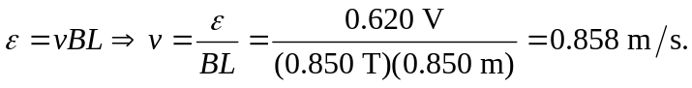
b) 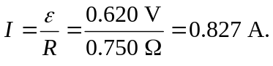
c) , to the left, since you must pull it to get the current to flow.

